**Lab - ANP-C9531 - More about classes**

**Assignment-1.**

● Write a Java program named Car

● The Car class should have the following attributes: make (String), model (String) , year (short) , and price(int) .

● The car class should have a constructor that takes all the attributes.

● Add a main method to instantiate car objects.

● The program should allow the user to create and display objects of each Car Class.

**CODE :**

package car;

import java.util.Scanner;

public class Car {

// Attributes of the Car class

private String make;

private String model;

private short year;

private int price;

// Constructor to initialize the car attributes

public Car(String make, String model, short year, int price) {

this.make = make;

this.model = model;

this.year = year;

this.price = price;

}

// Method to display the car details

public void displayCarDetails() {

System.*out*.println("Car Make: " + make);

System.*out*.println("Car Model: " + model);

System.*out*.println("Car Year: " + year);

System.*out*.println("Car Price: " + price);

System.*out*.println();

}

// Main method to create and display car objects

public static void main(String[] args) {

Scanner scanner = new Scanner(System.*in*);

// User input for Car 1 details

System.*out*.println("Enter details for Car 1:");

System.*out*.print("Enter car make: ");

String make1 = scanner.nextLine();

System.*out*.print("Enter car model: ");

String model1 = scanner.nextLine();

System.*out*.print("Enter car year: ");

short year1 = scanner.nextShort();

System.*out*.print("Enter car price: ");

int price1 = scanner.nextInt();

scanner.nextLine(); // Consume the newline character

// User input for Car 2 details

System.*out*.println("\nEnter details for Car 2:");

System.*out*.print("Enter car make: ");

String make2 = scanner.nextLine();

System.*out*.print("Enter car model: ");

String model2 = scanner.nextLine();

System.*out*.print("Enter car year: ");

short year2 = scanner.nextShort();

System.*out*.print("Enter car price: ");

int price2 = scanner.nextInt();

// Creating two Car objects

Car car1 = new Car(make1, model1, year1, price1);

Car car2 = new Car(make2, model2, year2, price2);

// Display the details of the cars

System.*out*.println("\nCar 1 details:");

car1.displayCarDetails();

System.*out*.println("Car 2 details:");

car2.displayCarDetails();

}

}

OUTPUT :

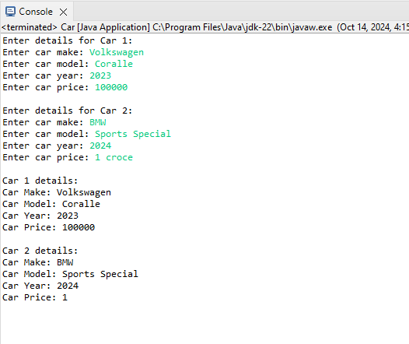

**Assignment-2.**

● Write a Java program that demonstrates method overloading by creating a class called Calculator.

● Add three methods called add().

● The first add() method should take two int variables as arguments and return their sum as int.

● The second add() method should take three int variables as arguments and return their sum as int.

● The third add() method should take two doubles as arguments and return their sum as double.

● The program should allow the user to display the results of each method.

Code:

package calculator;

import java.util.Scanner;

public class Calculator {

// Method to add two integers

public int add(int a, int b) {

return a + b;

}

// Method to add three integers

public int add(int a, int b, int c) {

return a + b + c;

}

// Method to add two double values

public double add(double a, double b) {

return a + b;

}

// Main method to display the results of each add method

public static void main(String[] args) {

Calculator calc = new Calculator();

Scanner scanner = new Scanner(System.in);

// Using the first add() method - two integers

System.out.println("Enter two integers to add:");

System.out.print("First integer: ");

int int1 = scanner.nextInt();

System.out.print("Second integer: ");

int int2 = scanner.nextInt();

System.out.println("Sum of two integers: " + calc.add(int1, int2));

// Using the second add() method - three integers

System.out.println("\nEnter three integers to add:");

System.out.print("First integer: ");

int int3 = scanner.nextInt();

System.out.print("Second integer: ");

int int4 = scanner.nextInt();

System.out.print("Third integer: ");

int int5 = scanner.nextInt();

System.out.println("Sum of three integers: " + calc.add(int3, int4, int5));

// Using the third add() method - two doubles

System.out.println("\n Enter two double values to add:");

System.out.print("First double: ");

double double1 = scanner.nextDouble();

System.out.print("Second double: ");

double double2 = scanner.nextDouble();

System.out.println("Sum of two doubles: " + calc.add(double1, double2));

}

}

OUTPUT:

